# Media Analysis - No need to demonize ChatGPT but AI regulation is a must _ Arab News

## Short Summary

The article is about the potential impact and regulation of ChatGPT, a large language model developed by OpenAI that has the ability to understand and respond to natural language, raising concerns over job displacement, plagiarism, and the need for AI regulations.

## Summary

Here are four bullet points summarizing the text:  
  
• ChatGPT, a large language model developed by OpenAI, has the ability to understand and respond to natural language, making it a valuable tool in various industries, including journalism.  
• The current version of ChatGPT can perform tasks such as writing essays, articles, and research papers, and even generating recipes, at an incredible speed, raising concerns about its potential impact on human work.  
• Education is one area where ChatGPT's presence is being felt, with universities and schools grappling with the issue of cheating and plagiarism, while medical professionals are also concerned about the possibility of machines making diagnoses and medical decisions.  
• The author argues that instead of demonizing AI, it could be a great equalizer for the have-nots in various fields, but regulations are needed to prevent it from tipping the balance in favor of AI.

## Question 1

The media frames the public discussion about ChatGPT as a double-edged sword, presenting it both as an exciting opportunity for human advancement and a potential existential threat to human work. The author mentions metaphors such as * Watershed historical moment implying significant change * Storm suggesting overwhelming impact * Threat emphasizing potential dangers * Great equalizer highlighting potential benefits

## Question 2

**Perspectives and Aspects being covered ** 1. The potential benefits of AI and ChatGPT in various fields, such as education, journalism, and medicine. 2. Concerns about cheating, plagiarism, and the loss of human jobs due to AI-generated content. 3. Limitations of ChatGPT, including mistakes, lack of recent information, and inability to understand nuanced prompts. **Aspects being ignored ** 1. The potential benefits of AI in developing countries, where it can help level the playing field in terms of access to knowledge and resources. 2. The need for regulations on AI usage is mentioned, but the specifics of what these regulations should entail are not discussed. Note that this question asks about perspectives and aspects being covered or ignored, so I focused on those specific topics mentioned in the text.

## Question 3

The answer is Not mentioned . The article does not specifically mention any contributions or advancements from the Arabic world related to AI or ChatGPT. However, it is mentioned that a news site CNET used AI to publish dozens of articles as an experiment in Saudi Arabia, but this is just one example and not representative of the Arabic world s role in AI.

## Question 4

The final message of the article is that AI regulation is necessary to prevent it from tipping the balance in favor of machines, with dire consequences .

## Sentiment

The sentiment is 3.0

## Entities

CNET, AI, OpenAI, Google, READ Learning, Arab News, Disclaimer Views, BBC, Generative Pretrained Transformer, Springboard, The New York Times, The Washington Post, fed, Post, Midjourney, Amal Mudallali

## Highlights

#7cc867#fb5b89#c885da#f9cd59

## Wordcloud for #7cc867 Highlights

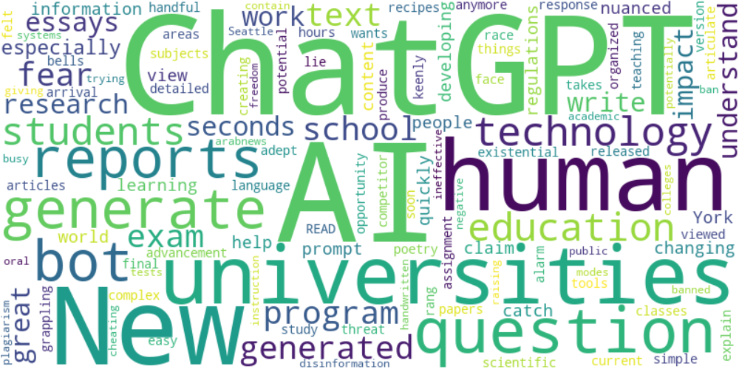

Top 10 words:

- ChatGPT: 9

- AI: 9

- human: 4

- reports: 3

- generate: 3

- bot: 3

- technology: 3

- education: 3

- universities: 3

- generated: 3

## Wordcloud for #fb5b89 Highlights

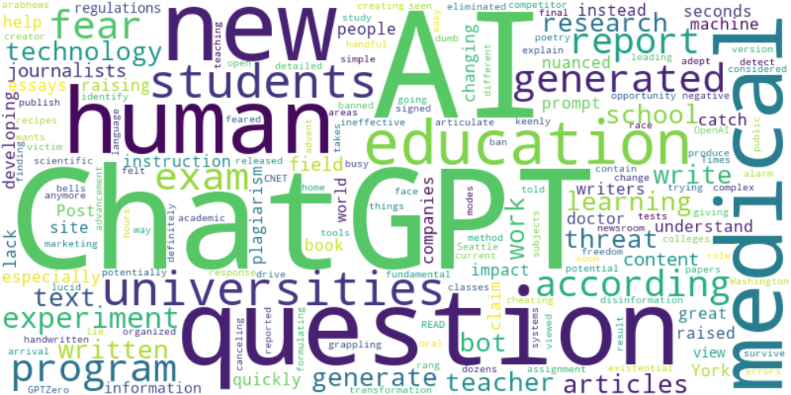

Top 10 words:

- AI: 18

- ChatGPT: 16

- human: 5

- education: 4

- question: 4

- generated: 4

- fear: 4

- questions: 4

- experiment: 4

- medical: 4

## Wordcloud for #c885da Highlights

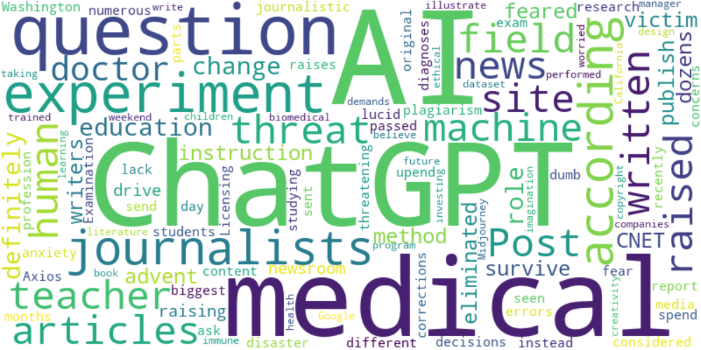

Top 10 words:

- AI: 9

- ChatGPT: 7

- experiment: 4

- medical: 4

- question: 3

- journalists: 3

- news: 2

- site: 2

- articles: 2

- according: 2

## Wordcloud for #f9cd59 Highlights

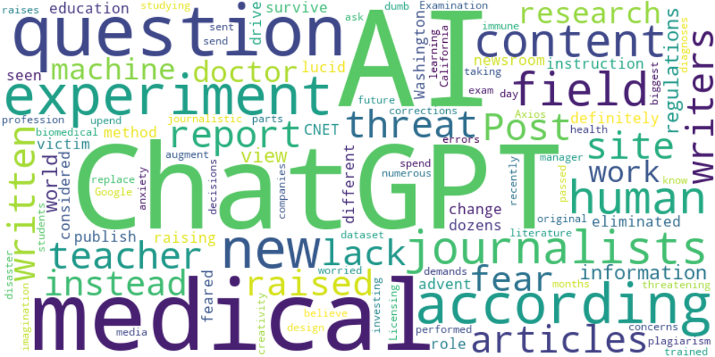

Top 10 words:

- AI: 12

- ChatGPT: 9

- experiment: 4

- medical: 4

- question: 3

- journalists: 3

- content: 3

- writers: 2

- news: 2

- site: 2